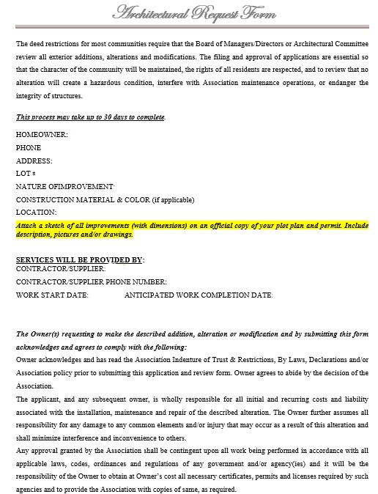

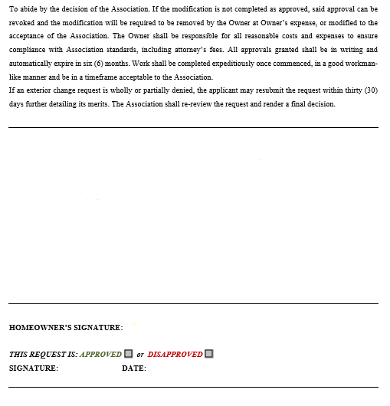

Email completed form including sketch, survey and/or Neighbor Acknowledgment form as required to:

Steur Management: [steurmgmt@leveledupme.com](mailto:steurmgmt@leveledupme.com)

WFHOA: [boardtrustees@wellingtonfarm.org](mailto:boardtrustees@wellingtonfarm.org)